5/19/2020

Student Name: xxxxxx

Student id: 000000

Business Strategy Report

Executive Summary:

Business strategy is set of objectives that represents a company’s vision in the future. Business strategy outlines a roadmap or success path by providing necessary steps and operations. Companies should set day-to-day functional level strategies in order to achieve goals long term business level strategies. In this report, a discussion on business strategies; both on functional level and business level is presented based on a leading company in Australia, Woolworths Group. The report shows their key strategies and proposes a few recommendations based on the strategies and their outcomes in the recent past.

Table of Contents

1. Introductioniii
2. Bodyiii

2.1 Functional Level Strategyiv

2.2 Business Level Strategy iv

1. Conclusionv
2. Recommendationsv
3. referencesvi
4. appendicesvi

1. Introduction:

Business strategy is a combination of decision plans in order to achieve some business goals in long term and to secure a position in the competitive business market. In other words, business strategy outlines the core objectives and the roadmap for a business which leads to the desired goals and also produces the ability to compete in the market (D. J.Teece, 2010). Success of a business is achieved by a making and executing a better business strategy. It gives the direction to the business goals and draws the ultimate vision. It also highlights the strengths and weaknesses, opportunities and threats. In this report, a detailed discussion on functional and business level strategies is presented based on an organizational context.

Business level strategies are set by a business unit to ensure their business goal by analyzing the competitive market and desired outcomes. They differ unit to unit based on their goals, purpose and market competition. The functional level strategies are set by different departments of business unit by breaking the business level strategies into smaller functions. These strategies are mostly focused on day-to-day operations, also keeping in mind the alignment of daily activity to the long term vision and objectives. They should aim to improve the efficiency, quality of the work as well as the innovation and customer responsiveness. Functional level strategies are made to support the business level strategies (Phil Megicks, 2007).

The selected organization is Woolworths Group, which is a large retail company with many operational business units. The scope of this report is only to discuss about their key business strategies in the local market (Australian market) by covering their business approaches or patterns during the past three to five years with a closer look to their functional level strategies and business level strategies. Also a few recommendation is proposed later in the report whether to justify their business strategies if their strategies are aligned with the business goals and competitive market, also to highlight their limitations in making and executing them.

1. Body:

Woolworths Group is the second largest Australian company by revenue which was founded in New South Wales on December, 1924. The company mostly offers retail operations throughout Australia and New Zealand. Till now, they have expanded their business to several divisions such as supermarket, liquor, finance, hotel, consumer stores etc. Their oldest business is supermarket business and they have become the largest supermarket chain in Australia by operating approximately thousand supermarket stores. The motto of the company is “Australia’s Fresh Food People” as they always try to provide fresh groceries by working closely with Australian farmers and growers. In this section, a discussion is presented on the company’s business strategies in their supermarket business division.

Woolworths Group has a customer oriented business strategy. They have long term goals to win customer’s trust as well as day-to-day functionalities to keep the customers satisfied. Keeping that in mind, they try to bring more innovative ideas, reduce cost by efficiency management and increase their brand value to compete in the market.

* 1. Functional Level Strategies:

The company make sure an intense collection and availability of their goods with consistent quality all over Australia. They try to create customer value by delivering best products every day and everywhere. They also scale across the local market by focusing on fixed production cost. Which increases their efficiency because they reduced unit costs attributes to a large output and spread fixed cost over a large production volume. To improve customer responsiveness they constantly refine their service delivering processes based on their customer’s behavior. They use customer insights and data driven statistics to determine customer choices. The supermarkets are divided into different segments so that customers can access easily. They analyze and personalize their customers, identify their shopping habits to provide high satisfaction. The company provides loyalty points to their old customers. Which also plays a big role in their relationship with their customers. To attract customers they always come up with better shopping experience by bringing new products categories, fresh food supply and processing facilities, new stores and refurbishments. Refurbishments are designed based on local customer preferences and prioritized in areas where they see the greatest potential for customer growth. (Woolworths Editorial, 2020)

These are day-to-day approaches Woolworths performs in order to improve efficiency, customer responsiveness, innovation and quality of their service. These functional goals also support their business level strategies in the long run. But as their concern is to improve customer responsiveness, they should introduce more technologies to their stores to improve the shopping experience like cashless payments, safe and secure online payments, computer vision based monitoring system. They can provide virtual assistants to recommend and assist the customers.

* 1. Business Level Strategies:

Business level strategies outline the objectives by which a company gain their competitive advantages. The main local competitors of Woolworths is, Coles Group and Aldi. To stay on top of the local market Woolworths ensures lower pricing and better ranging. This indicates their low-cost strategies. Woolworths provide a wide range of products with good quality at a lower price range to make sure their brands can attract and influence local customers. They also introduced their online shops to provide their services further more. Online pricing are aligned to in store pricing. (Woolworths Editorial, 2020)

They also provide offers to their targeted customer using loyalty system and promoting their own brands. Click & Collect locations are also opened including drive-thru collection points to increase customer convenience. These show their differential strategies to stay superior over their rivals. By the combination of these two strategies with a customer oriented mindset, the company provides best values to the customer.

These robust business level strategies help them to keep pace in the competitive market. Though as the world is moving towards digitalized systems. The company should set business goals to compete with their online or digital competitors whereas international brands are providing better services. Because customers are flexible buying their goods online. In order to do that, they should improve their home delivery systems along with mobile application and secure digital payment systems.

1. Conclusion:

Woolworth is a leading company in Australia and has been providing great values to their customers for a long time. Perfect anticipation and execution of business strategies made it possible for them. Long term business level strategies by analyzing the competitive market and providing best quality services with cost efficient production gave the company a vital edge in their day-to-day operations. And another key thing is, they always refine their strategies based in the current outcomes and results. That’s why a few recommendations is proposed by which they can improve and refine their business models and expand their business even more.

1. Recommendations:

* Use of emerging technologies: In 2018, Amazon introduced “Amazon Go” retail stores throughout United States. They have implemented a wide range of technologies to transform the conventional retail store into a cashier-less fully automated retail store (Amazon Go Editorial Staff, 2017). And they also set a new standard for the competitors in the retail industry. As people all over the world are more interested in technologies, customers are also satisfied with its automated functionalities. One recommendation for Woolworths is try to implement and adopt new technology as much as possible. They should spend time and money in research and innovation in order to facilitate the customers with better technologies. A few recommendations can be implementing cashless payments by secured online transactions, provide virtual assistants such as chat bots, voice assistants, user-friendly mobile and web applications, automated monitoring systems etc. Also Amazon Go reduced their cost by eliminating their human resources from the retail stores. This can be inspiring for Woolworths as well.

From the SWOT (Strength, Weakness, Opportunity, Threat) analysis (Appendix A), this recommendation can be in the opportunity grid which works as an external factor that can affect the company’s performance. The best way to assess an external factor is to perform a PESTEL analysis to determine whether the opportunity is good for the organization or not. The PESTEL (Political, Economic, Social, Technological, Environmental and Legal) framework suggests technology as an important macro-environmental factor (Appendix B) and it plays a vital role for a company that would disrupt older strategy and contribute in digital transformation.

* Improving digital business model: The Company should explore their digital strategies like digital marketing, promotions, services. Because during the last decade business infrastructures have become more digital (A. Bharadwaj et. al, 2013). They should work on their e-commerce business model more to improve because the future is online and people are now preferring the online shops more than before. To ensure better online experience, they should provide seamless online experience, improve their home delivery systems, and provide more offerings to their online customers etc. E-commerce can provide more insightful data and they should pay attention more towards data, data-driven algorithms and artificial intelligence. They should promote their brands in digital markets, social media and other digital platforms in order to reach more customers.

We can determine this as the weaknesses for the company not having dominance over digital platforms. So the company should plan mini-mini strategy (Appendix A) where they should try to minimize the weaknesses and threats and maximize the opportunities. Also they can follow the porter’s five forces framework where competitiveness on a market is the main issue. According to the framework, competition in a business market depends on five forces such as 1. Threat of new comers; in this case e-commerce and digital platforms are entering business every day and attracting customers, 2. Bargaining power of suppliers; in this case a lot of options in the digital platforms with better pricing, 3. Bargaining power of buyers; buyers have more options to pick from, 4. Threat of substitute products or services; plenty of options on the internet, and 5. Existing industry rivalry; world leading e-commerce websites are already available in the online market.

1. References:

D. J.Teece. 2010. Business Models, Business Strategy and Innovation. In *Long Range Planning*

*43(2-3), pp. 172-194.*

Phil Megicks. 2007. Levels of strategy and performance in UK small retail businesses. In

*Management Decision, Volume 45, Number 3, 2007, pp. 484-502(19).*

Woolworths Editorial. 2020. Our Strategy. Available at:

<https://www.woolworthsholdings.co.za/overview/our-strategy/>

Amazon Go Editorial Staff. 2017. Amazon Go. Retrieved from *Amazon Website -*

[*https://www.amazon.com/b?node=16008589011*](https://www.amazon.com/b?node=16008589011)

A. Bharadwaj, O. A. El Sawy, P. A. Pavlou and N. Venkatraman. 2013. In *MIS Quarterly*

*Vol. 37, No. 2, pp. 471-482*

Appendices:

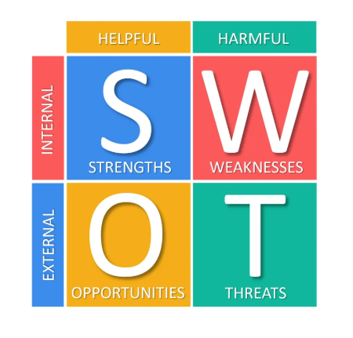

Appendix A: SWOT Analysis 2x2 matrix

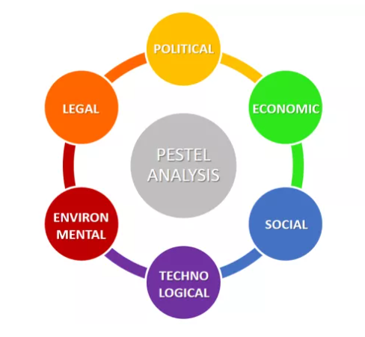

Appendix B: PESTEL Analysis factors